Association Management Models and

Their Impact on Financial Performance

  - Prepared by James Gaskin, Ph.D.
Brigham Young University

  - Commissioned by
AMC Institute (AMCI)

  - Final Report
July 2015

Executive Summary

KEY FINDINGS
In general, using AMCs is associated with stronger financial performance.
Regardless of tax status and budget size, growth in Net Income, Net Revenue, and Net Assets are stronger for associations using AMCs.
The only organizational context in which using AMCs did not lead to higher performance was with regards to average percent surplus for 501c6 organizations.
On average, AMC-managed associations experience more than three times the growth in net assets and 31 percent more growth in net revenue regardless of size and tax status than those that do not use AMCs.

Background:
AMC Institute commissioned a research investigator (RI), James Gaskin, PhD of Brigham Young University, to conduct a rigorous study of associations’ financial performance based on management models.
The following questions were posed:
Are there differences in the financial performance between associations using AMCs versus those not using AMCs?
How do these differences manifest in general, across 501(c)3 and (c)6 organizations, and across small and large budgets?

Methodology:
NTPA directory of national/international associations with budgets ranging from $500,000 to $7.5 million; filtered out associations that serve as AMCs. Random list generated 167 associations.
Obtained IRS Form 990 for all 167 associations (501c3, 501c6 only). Data analysis was stratified by c3 and c6 organization type and budgets of $500K to $2 million and $2 million to $7.5 million.

Results:
The table below summarizes the relative financial performance of associations managed by an association management company (AMC) vs. those not managed by an AMC. Green reflects a higher value for associations managed by AMCs, while red reflects a lower value. Data was culled from IRS form 990s of 501c3 and 501c6 organizations. A random sample was drawn of 167 associations. The low budget category was between $500K and $2 million. The high budget category was between $2 and $7.5 million

Measure | ALL | c3 | c6 | Low$ | High$
Net Total Rev Growth | More | More | More | More | More
Net Income Growth (surplus) | More | More | More | More | More
Avg Percent Surplus | More | More | Less | More | More
Net Asset Growth | More | More | More | More | More
Revenue Diversity in Products | More | More | More | More | More

.
Median Net Total Revenue Growth
15%

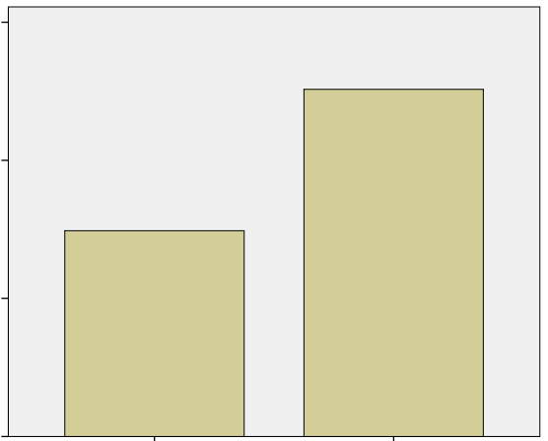
In general, associations using AMCs have stronger net total revenue growth than those not using AMCS
7.45%
12.57%
0%
5%
10%
Not Using AMCs
Uses AMCs
Not Using AMCs

Median Net Total income Growth
15%

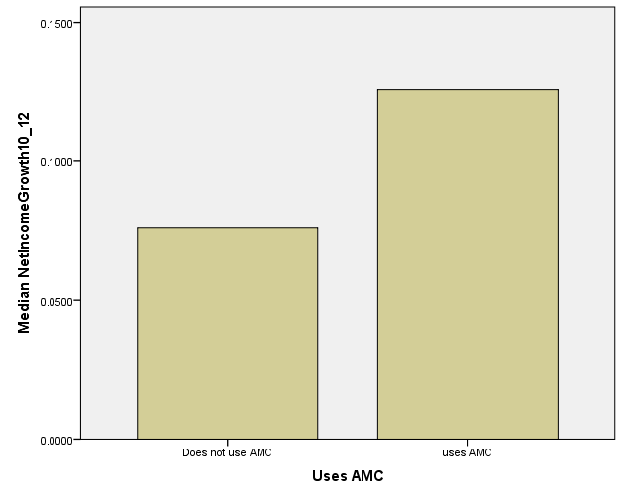
7.61%
12.57%

In general, associations using AMCs have stronger net total income growth than those not using AMCs
10%

5%

About AMC Institute
AMC Institute advances professionalism and high industry standards for association management companies. We provide expert support and resources to drive new business to our members and keep them in the forefront of emerging trends and knowledge. We champion accreditation to promote industry best practices and create educational and networking opportunities for AMCs to engage and learn from each other.
The AMC Institute represents over 180 association management companies that manage more than 1,800 associations, with a total of their budgets exceeding $1 billion.

About Association Management Companies
Association management companies, or AMCs, are for-profit businesses that manage associations to help them grow and prosper. They offer the expertise, staffing and resources that allow professional societies, trade groups, not-for-profits and philanthropic organizations to effectively manage day-to-day operations and advance their long-term goals. AMCs deliver high levels of expertise and accountability so that associations can continue to increase their value and relevance to members and achieve measureable results.
AMCs provide their clients with unparalleled flexibility, agility and financial advantages, which makes the AMC model a good alternative for managing many nonprofit organizations.

